SIMATS ENGINEERING
ASSESSMENT TOOL 1: Short Answer Test

COURSE NAME: Cloud Computing and COURSE CODE: CSA15
Big Data Analytics

COURSE OUTCOME COVERED
CO1: Apply cloud computing technologies including hardware-software evolution, virtualization, web services, and service models to develop cloud-based solutions. (BL2)

Dave's Taxonomy: Imitation (Level 1) Total Marks: 25
Question Count: 5

Code of Conduct
I _Pathakamuri uday krishna Advani /1925260229_________________________________________________________________ (Name / Reg. No.)
certify that this submission is my original work and that I have adhered to the guidelines specified for this assessment.
I understand that any violation of academic integrity rules will result in disciplinary action. Signature of the student: ____________________________________

Assessment Tasks Short Answer Test

- Define cloud computing and explain any four characteristics that make it different from traditional onpremise computing.
- Trace the evolution of cloud computing from hardware evolution to internet software evolution, and show how these changes enabled modern cloud platforms.
- Explain the role of server virtualization in cloud computing. Differentiate between virtualization as an enabling technology and cloud computing as a service model.
- Discuss the role of data centers in delivering cloud services..
- Differentiate IaaS, PaaS, SaaS, and XaaS with one suitable real-world example for each model.

Short Answer Test Rubric

Criteria | Weightage | Level 4 -  Exemplary | Level 3 -  Proficient | Level 2 -  Developing | Level 1 -  Beginning
Conceptual Accuracy | 30% | Accurate definitions and precise  explanation of all key terms | Mostly accurate with minor gaps | Partial understanding  with noticeable errors | Incorrect or irrelevant explanation
Coverage of Concepts | 20% | Covers all expected subpoints completely | Covers most expected points | Covers only basic points | Very limited coverage
Use of Examples | 15% | Uses highly relevant cloud examples to  strengthen the answer | Uses relevant examples with minor mismatch | Uses vague or partially relevant examples | No useful examples
Comparison / Differentiation | 20% | Clearly distinguishes  concepts with strong logic | Reasonable differentiation  with minor overlap | Comparison is weak or incomplete | Fails to differentiate concepts
Clarity of Expression | 15% | Clear, organized, and  concise answer writing | Generally clear with few issues | Understandable but poorly organized | Difficult to follow

Total Marks:

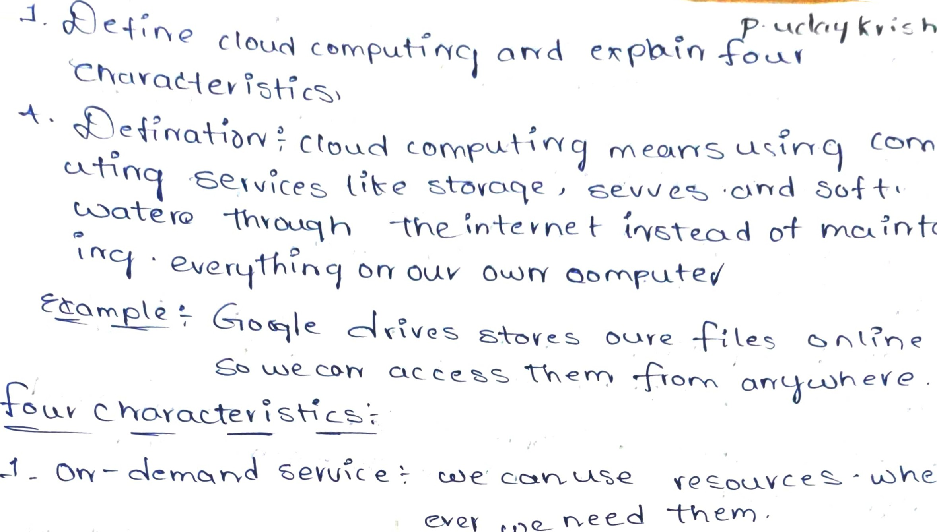
e
e.DQ__
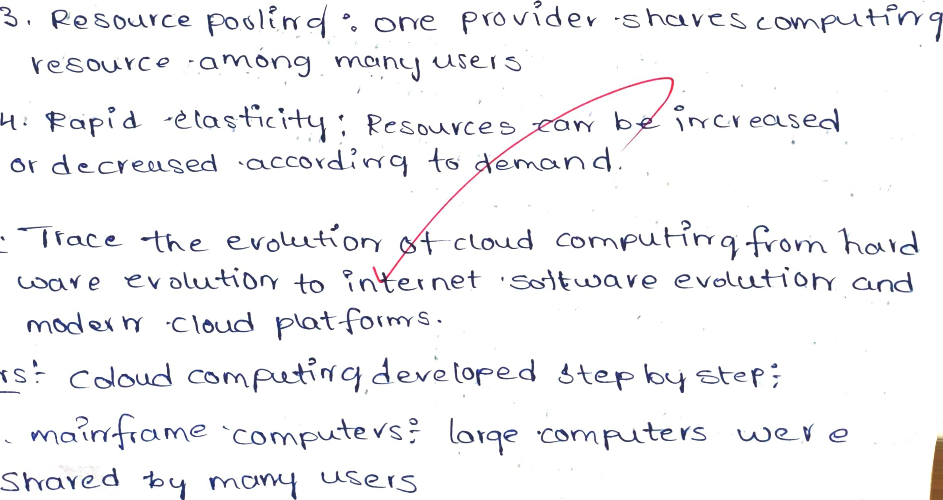
Fe ö • ER-cxy+e-cl  ÎndîUîd
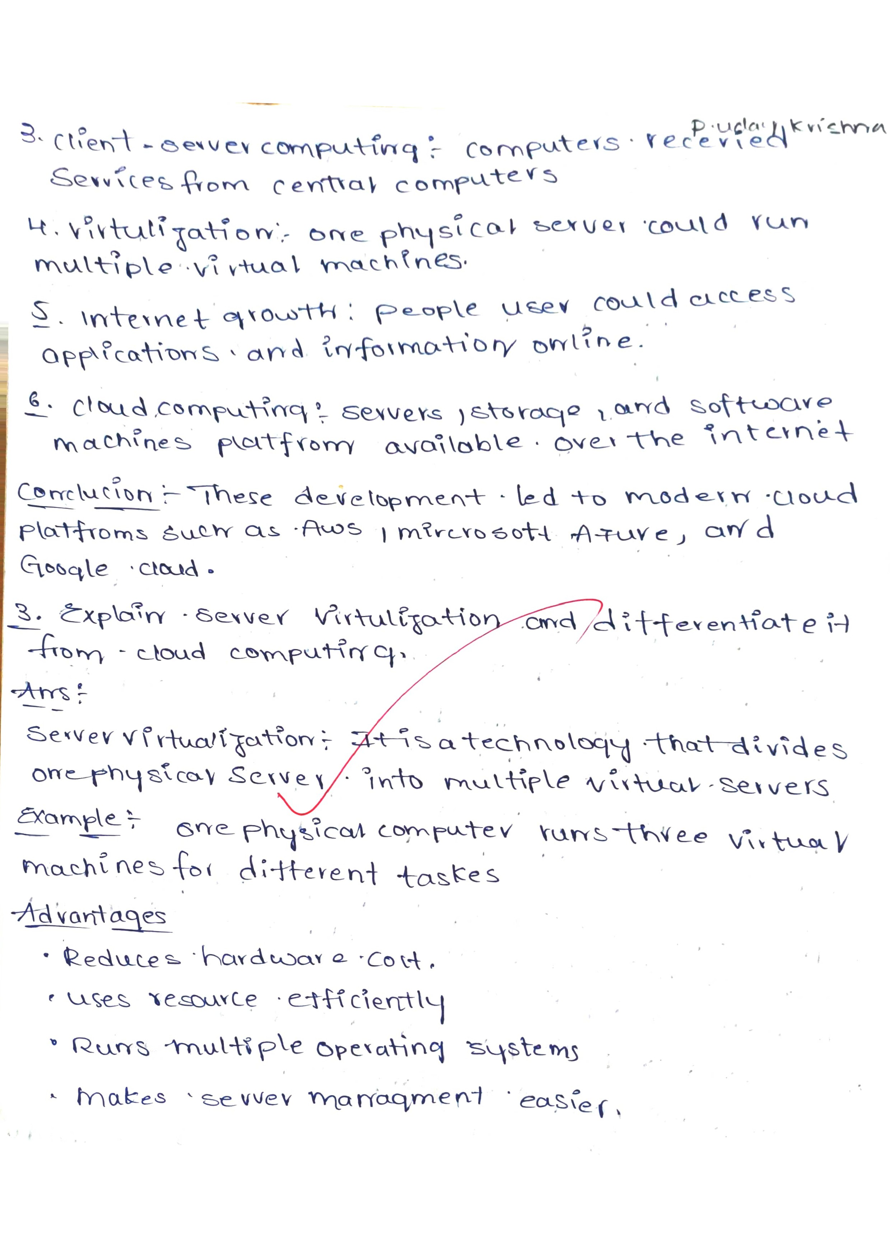
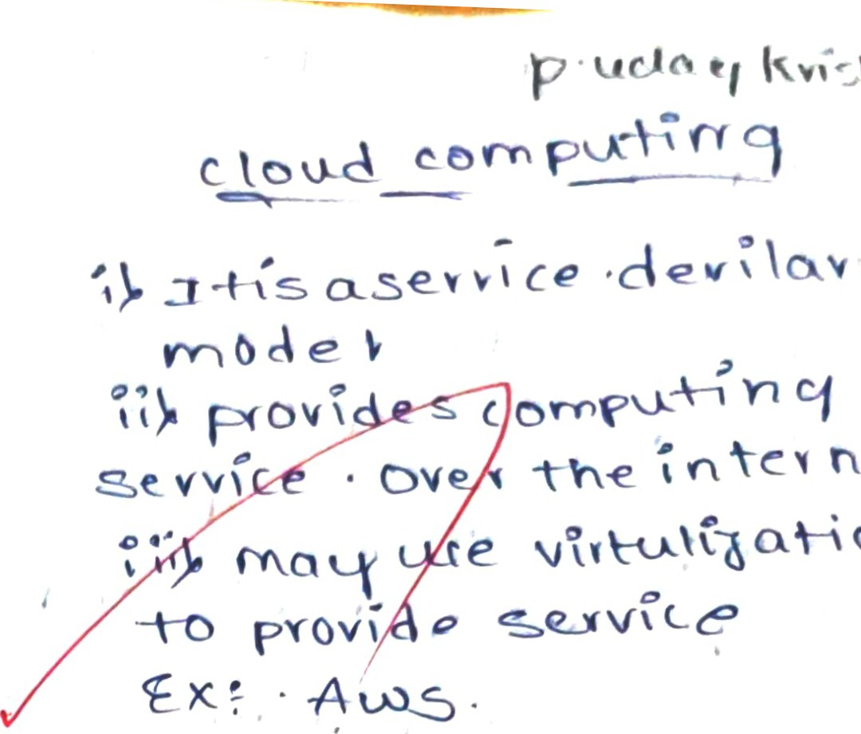
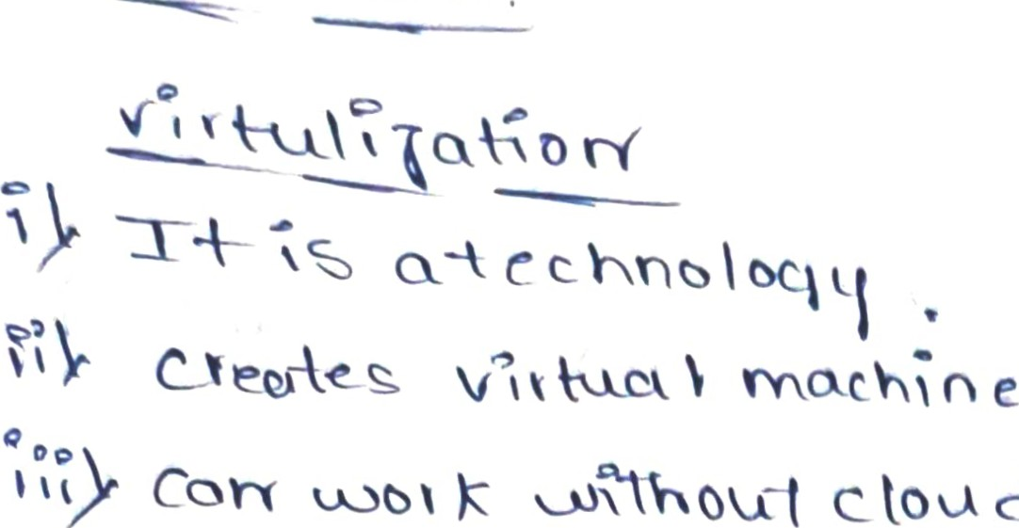

e 'ence •
cloud
v ces
vole

—A--•YYS
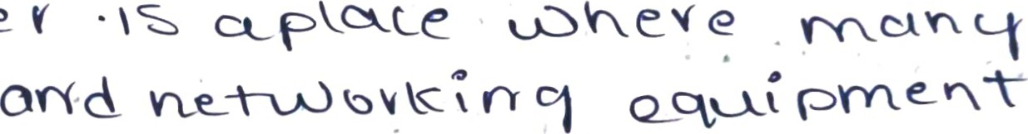
A •cenfie v SO V e v
•f-ovQqe •Ate vices ) ewe
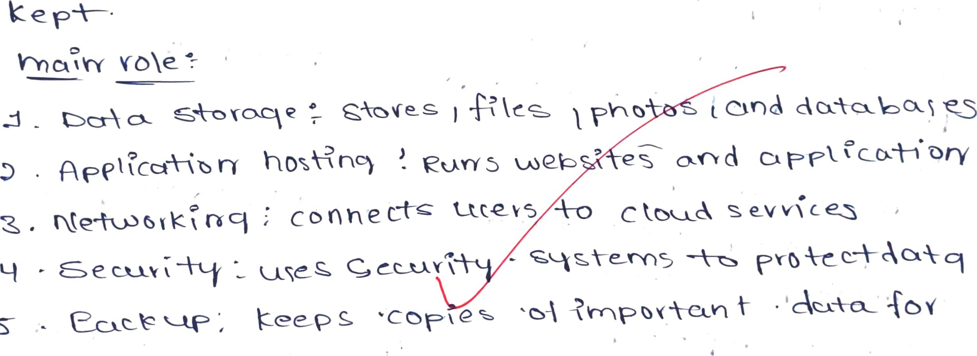
V ecoveveb
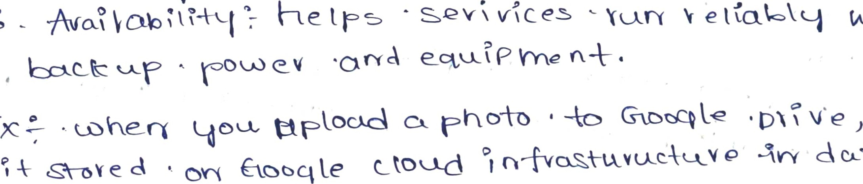

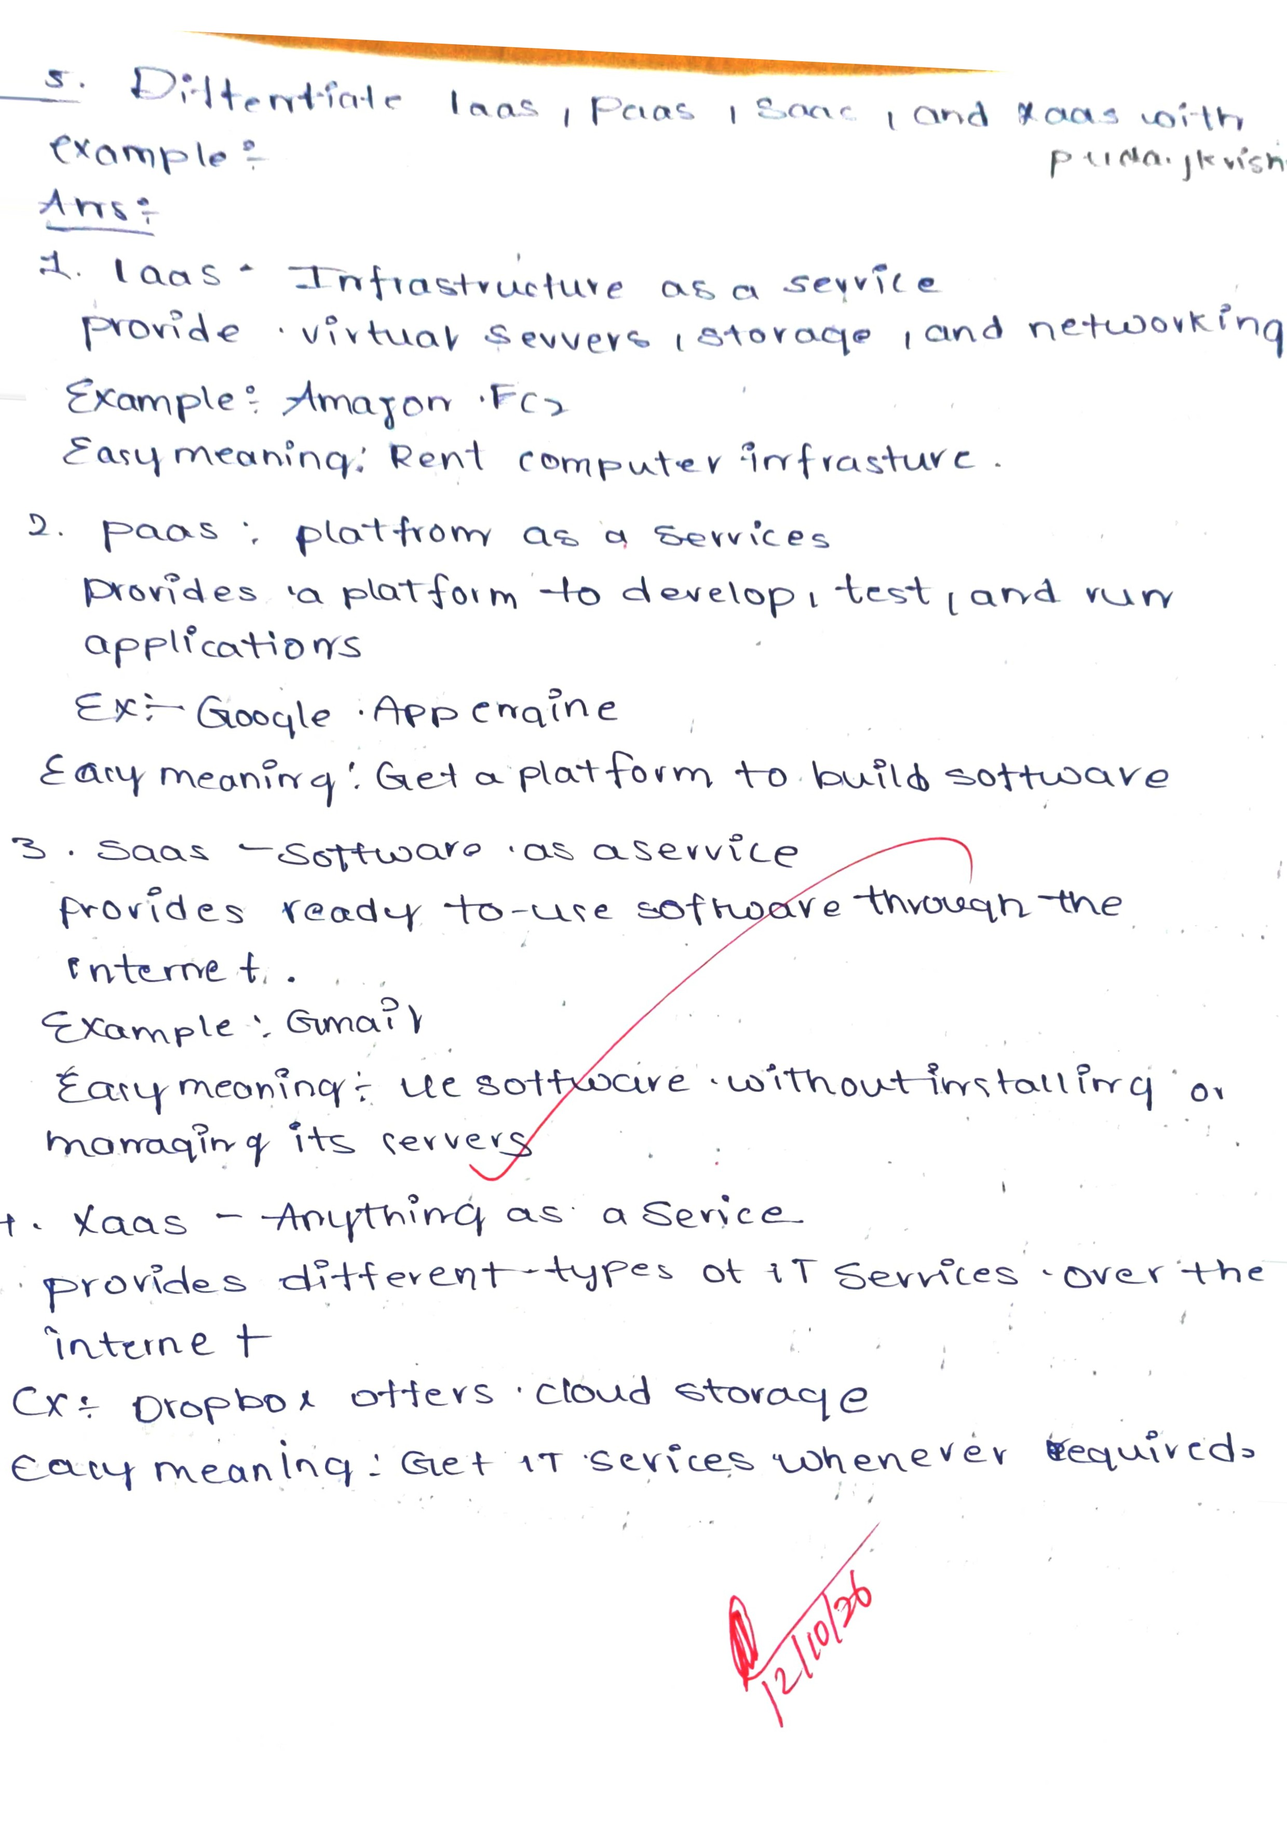
CT

